Parth Babbar

voice banking services

Introduction:
Voice banking services use cutting-edge voice recognition technology, allowing clients to complete a range of financial transactions and queries using voice commands. This article provides an in-depth review of voice banking in the United States, including its existing capabilities, benefits, difficulties, use data, future potential, and possible remedies. Voice banking, which uses virtual assistants like Amazon Alexa, Google Assistant, and Apple Siri, offers a hands-free banking experience, revolutionising how clients engage with their financial institutions.
Key Features:
- Balance Inquiries: Use voice commands to check your account balance.
- Transaction History: Request recent transaction information.
- Fund Transfer: Transfer money across accounts or to other people.
- Bill Payment: Pay bills with voice commands.
- Customer Support: Contact customer support by phone.
Benefits:
- Convenience: Customers may complete banking transactions hands-free, which improves convenience and accessibility.
- Accessibility: Especially useful for those with impairments or who prefer conversational interactions over traditional banking procedures.
- Efficiency: Reduces the need for manual inputs and navigation through apps or websites, hence speeding up routine transactions.
Challenges:
- Security Concerns: Use strong authentication techniques to prevent unauthorised access and secure client data.
- Accuracy Issues: Handling dialect variances, background noise, and speech subtleties, which can all have an impact on voice recognition accuracy.
- Privacy: Protecting sensitive consumer information while adhering to data protection requirements such as GDPR and CCPA.
Solutions:
- Security: Using biometric voice recognition (e.g., voiceprints) and behavioural analytics to improve authentication procedures.
- Accuracy: Using machine learning to improve AI models and adjust to regional dialects and ambient noise.
- Privacy: Using strong data encryption technologies and strict privacy measures to safeguard consumer information from unauthorised access.
Future Trends:
- Advanced AI Integration: Offers personalised financial insights and proactive suggestions based on user behaviour and preferences.
- IoT Integration: Providing voice-controlled banking via smart home devices that integrates easily into daily activities.
- Voice Commerce: Expanding voice banking capabilities to encompass non-banking activities like retail purchases and utility payments.
Banking Providers:
- Bank of America: Integrates its virtual assistant, Erica, into its mobile app, allowing consumers to complete different banking operations using voice commands.
- Wells Fargo: Provides voice banking through its mobile app and integrates with virtual assistants such as Amazon Alexa and Google Assistant.
- Capital One: Offers voice banking with its Eno virtual assistant, which is available on both mobile and online platforms.
- JPMorgan Chase: Voice banking has been incorporated into the smartphone app, allowing consumers to check balances, transfer cash, and do other tasks using voice commands.
- Citibank: Provides voice banking services via its mobile app and works with smart device makers such as Amazon and Google.
Statistics:
- As of 2023, around 26% of US people had utilised phone banking services.
- The voice banking market is estimated to develop at a CAGR of 15.7% between 2023 and 2028.
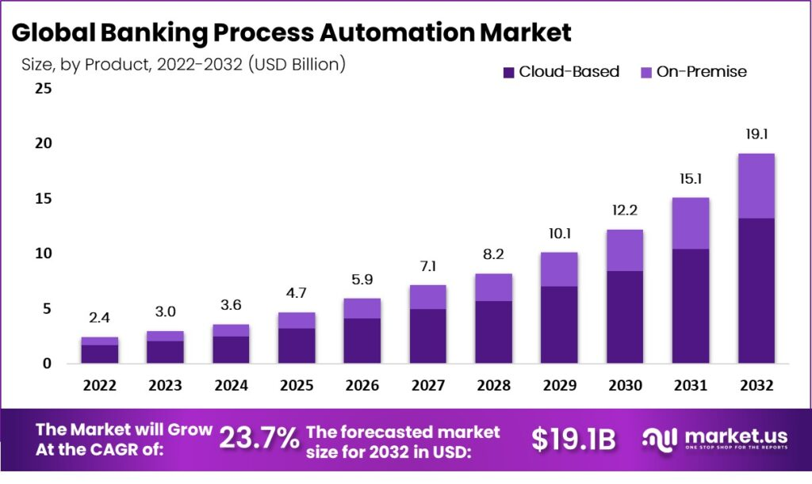
- Younger demographics (18-34 years) utilise voice banking services at a higher rate than older age groups, with 35% utilising them on a regular basis.
Conclusion:
Voice banking services represent a disruptive trend in the financial industry, providing users with exceptional ease and accessibility. While problems like as security, accuracy, and privacy remain, continued technological developments and regulatory compliance are expected to promote additional acceptance and innovation in voice banking services across the US market.

